

HOLMBUSH PRIMARY ACADEMY
Hawkins Crescent
Shoreham-by-Sea
West Sussex
BN43 6TN
Telephone 01273-592471
Tel/Fax 01273-592660

Email office@holmbushprimaryacademy.org.uk
www.holmbushprimaryacademy.org.uk

Head of Learning: Ms Rebecca Jackson BEd Hons, MA Ed, NPQH

June 2015

Dear Parents and Carers,

I am writing with exciting news about how our classes will be organised from September.

Three years ago we made the decision at Holmbush to mix our Year 5/6 classes and it has been very successful with better transition to the next stage, and great end of key stage results which have improved, particularly at the higher levels.

At the time, parents and carers were concerned about this change, but we were pleased with the feedback later that showed we had made the right decision.

‘From my perspective it has helped my daughter make new friends and prepare her for the transition to secondary school. I also think that the mixing of classes is beneficial as we are such a small school and without the class mixing a child could go through their whole primary school experience with only a small group of people.’ Parent

‘I found mixing classes an excellent opportunity for my son, especially in a one form entry school. When he was the youngest in the class he looked up to others and gained motivation to achieve better because of what he could see. When he was one of the oldest it gave him an opportunity to work with younger children and encourage them, which again boosted his confidence no end.’ Parent

‘It’s fun because you get to mix with another year group so you can get on with other children.’ Y5 boy

‘It’s good getting to meet and be with older and younger children.’ Y6 girl

‘The older children can help you learn.’ Y5 boy

‘I was a bit shy when I first started in a mixed class but it got better and I settled quite quickly.’ Y6 girl

As you are aware at Holmbush our learning journeys are on a two-year cycle, which supports the planning of the curriculum. So, Years 1 and 2, Years 3 and 4, and Years 5 and 6 plan in teams. This ensures the curriculum is covered in enough depth and that resources and expertise can be shared. The new National Curriculum, which came in last September, is set out and organised in the same way with Key Stage 1 covering Years 1 and 2, Lower Key Stage 2 covering Years 3 and 4, and Upper Key Stage Two covering Years 5 and 6.

As a one-form entry academy, one of the greatest issues we face is providing the children with a depth of social and personal skills when they are in single form classes for several years. This has become an increasing challenge as our classes have become less equal in gender over the last few years. For example we have a class with 25 girls and 5 boys and we have a class of 18 boys and 11 girls. Therefore, to build on the success of our mixed upper key stage two classes and to provide all the children with a wider range of social and personal skill building opportunities the governing body has made the decision to mix Years 3 and 4 and Years 1 and 2 from September.

This will give all the children greater flexibility in friendship and learning partner choices and experiences. It will also enable us to support children’s developing standards of achievement and attainment in the new curriculum with a more focused approach on individual paths to progress.

If you have information that you feel will be relevant to how the classes are mixed and planned for next year, e.g. friendships and good working relationships, we want to hear about it. You can email in to office@holmbushprimaryacademy.org.uk, complete a contact form on the website, drop us a note or let your child’s class teacher know. We need this by Wednesday 10th June. We will be asking the children for their ideas and with whom they would like to be in the next fortnight. Classes will then be planned by their current class teachers and matched to teachers, and you will have this information by the end of June.

We are sorry to be saying goodbye to Mrs Sheila Boniface and Mr Ian Hudson this year as they move on to other things. We will miss their expertise and experience greatly, and wish them all the best.

The governing body have appointed two new class teachers for Holmbush Primary. Both have already been teaching children locally across Key Stage Two. Miss Emily Hodgkinson and Mrs Sarah Collins will be joining us soon. Miss Stickley will not be taking a class from September so she can concentrate on developing innovation in the curriculum, and monitoring the academy’s progress with Ms Jackson.

We look forward to your support on this next phase in our academy’s development from good to outstanding.

Yours faithfully

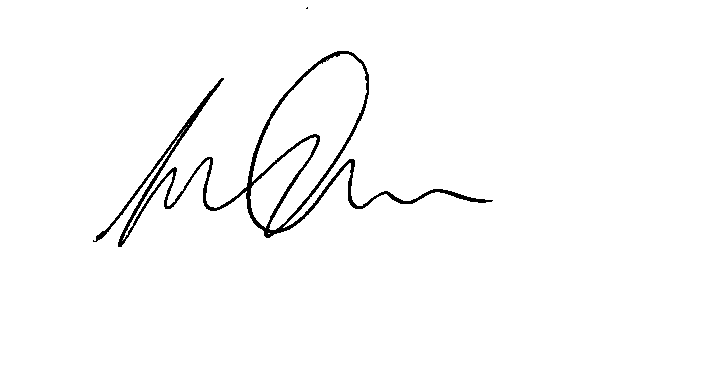

Rob Gamon
Chair of Governors

